OBSTETRA
ELECTRONIC DELIVERY BED, COLUMNAR MOTORS
Click for detailed video of the product
- Electronic adjustments of backrest, legrest, height-up & down positions
- Electrical operated Trendelenburg and Reverse Trendelenburg positions.
- Metal parts coated with zinc phosphate and varnished with an electrostatic epoxy-polyester powder
- Easily cleanable, 3-section (HPL) compact laminate mattress surface.
- X-Ray permeable lying surface
- Converting to Bed
- Removable headboard and footboard made of hygienic PP materials.
- Tuck-away side rails made of hygienic PP materials
- IV pole receptacles and on the two corners of the headboard
- Rotating protective bumpers at all (four) corners of the bed
- Height adjustable IV pole
- Pair drainage hooks at both sides of the bed.
- Stainless steel accessory rails
- 125 mm diameter swivel castors with central locking system and directional lock
- Nurse control panel
- Electronically CPR (Reset)
- Equipped with powerful column motors
- Two-piece ABS plastic covered lower chassis
- Stainless steel accessories corrosion resistant
- Removable stainless steel fluid basin
- Adjustable patient hand grips
- Sliding foot section mechanism
- Angle indicators on the side rails for the backrest, Trendelenburg and Reverse Trendelenburg positions.
- Back up battery for non-stop operation in case of power failure.
- Foam mattress of 12 cm thickness and 28 kg/m³ suitable for lying surface with antibacterial & flame retardant cover
- Adjustable Leg supports
- Squatting Bar
- Upholstered heel Supports (foot support)
- Manual CPR for the backrest
- Accessory Trolley
- Control panels embedded on side rails (optional)
- Twin castors of 150 mm diameter (optional)
- Foot switch (optional)
Obstetra Delivery Beds & Obstetra Gynecology Tables
 | TECHNICAL DETAILS
 | Backrest Angle: 0°-67° | Bed Surface (Extended): 85×191 cm
 | Pelvic Angle: 0°-27° | Bed Surface (Retracted): 85×144 cm
 | Trendelenburg Angle: 0°-20° | Height (without Mattress): 60-100 cm
 | Reverse Trendelenburg Angle: 0°-20° | Mattress Thickness (Backrest and Pelvic Sections): 12 cm
 | External Dimensions: 109×209 cm | Castor Diameter: 125 mm
 | Product Weight (Empty): 140 kg | Safe Working Load Capacity: 250 kg

 | ELECTRICAL DATA
 | Power In | : Max. 3,15A, 100V – 240V ~ 50/60 Hz
 | Electrical Shock Protection | : Class I, Type B
 | Liquid Ingress Protection | : IPX6
 | Battery | : 2x 12V Series Connected, sealed, rechargeable, Lead / Acid gel, 1.2 amp hrs.

ACCESSORIES
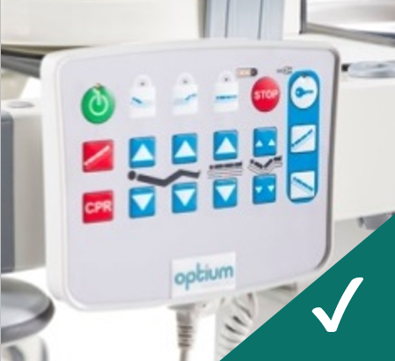
Nurse Control Panel
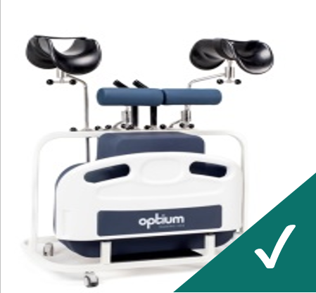
Accessory Trolley
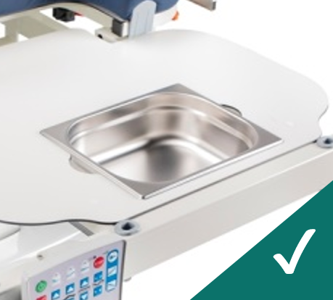
Stainless Steel Waste Bowl
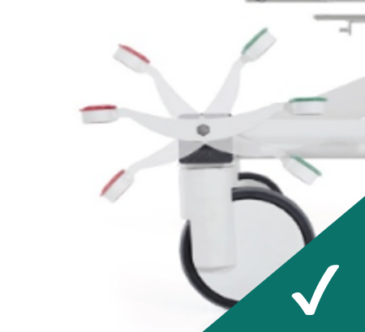
Central & Directional Lock Castors, 125 mm
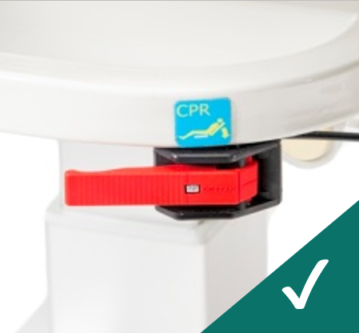
Manual CPR
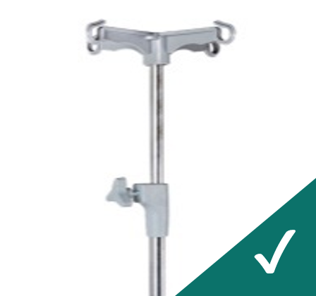
IV Pole
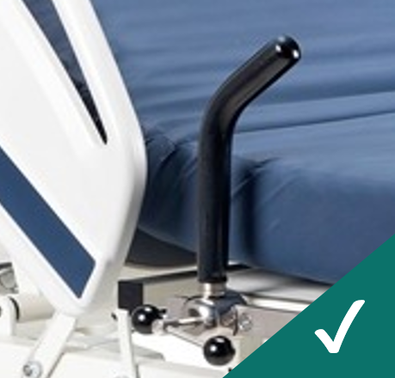
Hand Grips
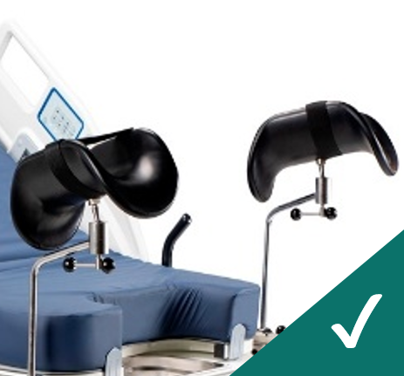
Adjustable Leg supports
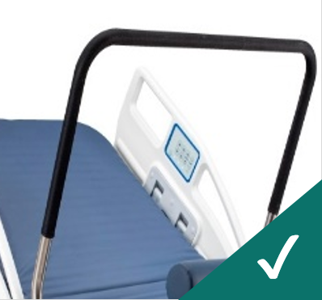
Squatting Bar
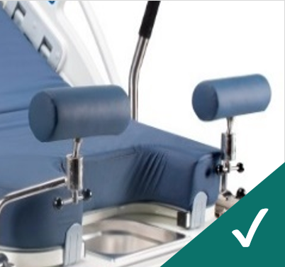
Upholstered Heel Supports
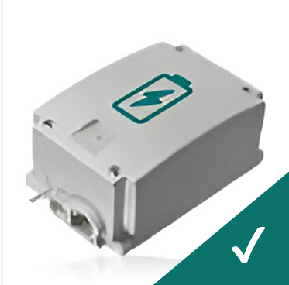
Rechargeable Battery Backup
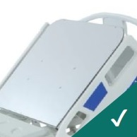
X-Ray Translucent HPL Backrest
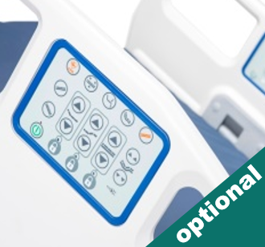
Control Panels Embedded on Side Rails
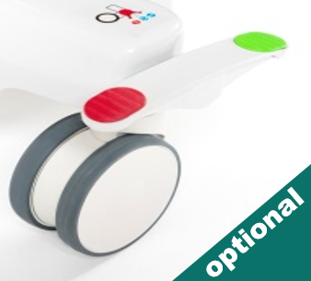
Twin Castors, 150 mm
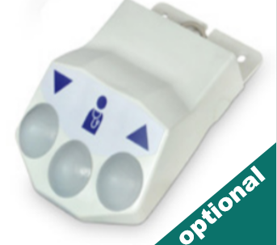
Foot Switch

